SSOUTHEND PIER

[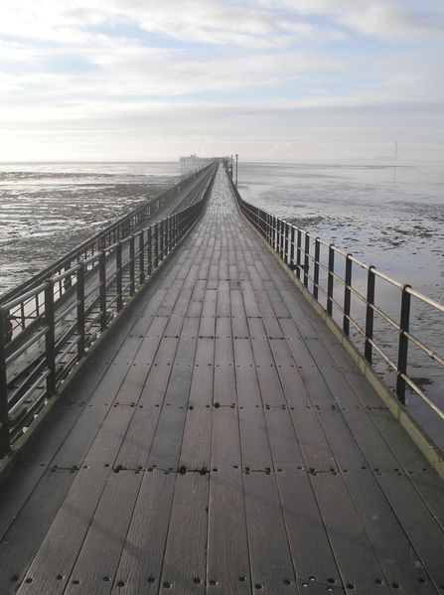](http://upload.wikimedia.org/wikipedia/commons/c/c4/Southend_Pier.jpg)

This pier was built in the 19th century and has had to endure a number of fires, of which the most recent one was by far the worst. A huge portion of the pier was swept away. In the onslaught thee station, gift shop and amusement arcade, plus a number of other things disappeared in the Southend pier inferno.

The pier, the longest in the world, has to have trains due to its long length.

The first trains were open sided toast rack trams. These were replaced in 1949 by trains that looked like motor coaches. These ran until 1974, and were replaced by the trains that are still running.

The pier has a museum which shows the Southend Pier timeline, the original trains and old penny slot machines.

An amusement arcade backs onto Southend Pier.

Nearby is the fictional double deck pier in which people are taken by elephants to the end of the pier- on the top deck.

On the lower deck people have to swim along the pier to get to the other end, or they are taken by a motor settee to the other end.

If the pier was 20 miles long it would have hotels along various sections, and there would be a transit line that would connect the pier with Southend Station. The pier would also have a football pitch on the pier.

One theory for the fire is that it was started by a blaze worm, a sea creature that has flames shooting out from its body, or a fire breathing dragon. Another theory is that the fire was started by the sun jumping down on top of the pier.

The pier is now sprayed with a blaze worm repellent to stop these monsters from coming out from under the sea to attack the pier. Another menace is a the Fiery Man, a dangerous human being that uses its body to attack and set fire to objects.

The Fiery Man lives up in the sky he regularly comes down to set fire to landmarks but is stopped in his tracks by a sky policeman.

The pier has a restaurant that serves gigantic meals on plates two feet wide, ‘and ‘ a meal served for one person on these giant plates for one person is really meant for twelve people. Only a man with five stomachs could eat the huge portion that’s served to him. The chips with this dinner are enormous, each one measuring a foot.